**1- Overall system design and architecture:**

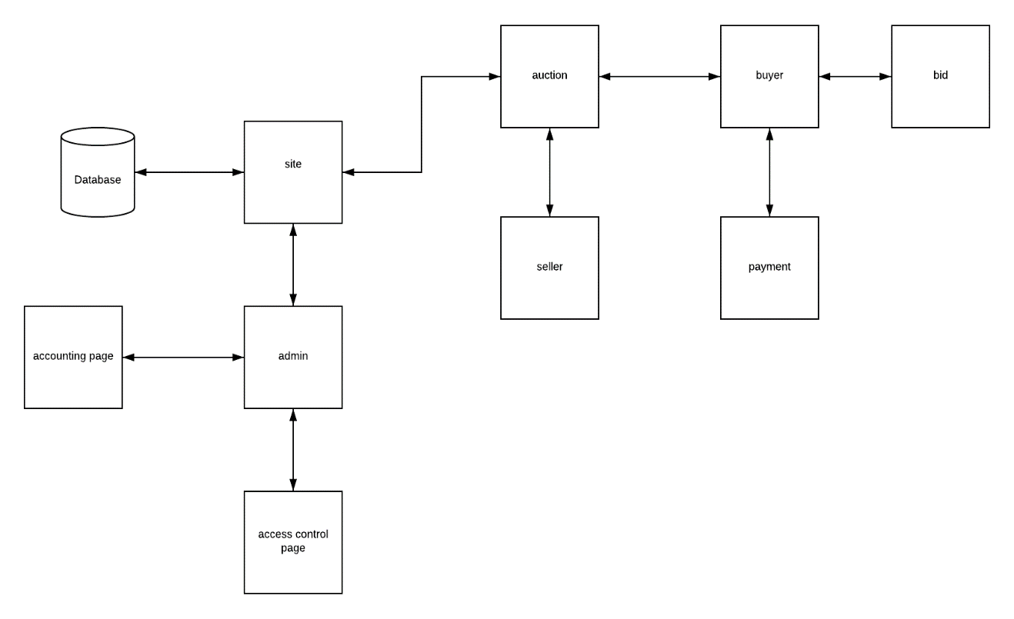

**4- Class and method design:**

**Method name:** create account

**Client:** user (buyer, seller)

**Programming language:** VB

**Description:**

user enter his info like (first name, last name, e-mail, payment method, birth date, gender, region, phone number) to create account.

**Pseudocode:**

User must enter all the necessary fields, if he misses a field or entered wrong info a message box will appear with error message for the field, else if there was any duplication in the unique fields, error message will appear for that field, else account will be created and info will be saved in database.

**Method name:** log-in

**Client:** user (buyer, seller, admin)

**Programming language:** VB

**Description:** user enter his username and password to go to his page.

**Pseudocode:** user enters his user and pass, if he enters false username or pass error message will appear, else if he misses field error message will appear, else he will be directed to his home page.

**Method name:** create auction

**Client:** user (seller)

**Programming language:** VB

**Description:** seller enter a product with details and the starting bid to create an auction.

**Pseudocode:** seller enters product with its details, if he misses field error message will appear, else an auction will be created.

**Method:** payment

**Client:** buyer

**Programming language:** VB

**Description:**

**Pseudocode:**